**TASK 1**

**Objective:**

Write a program to open a file myfile .txt and write “Hello students this computer programming class”.

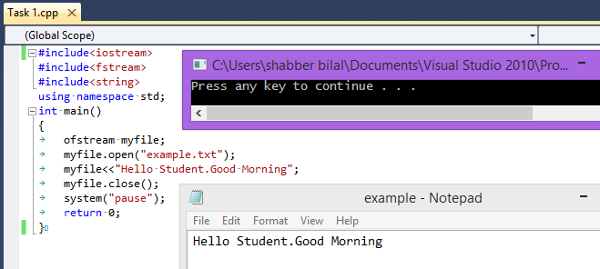

**TASK 2**

**Objective:**

Write a program to read a list of students from file and print the list and number of students.

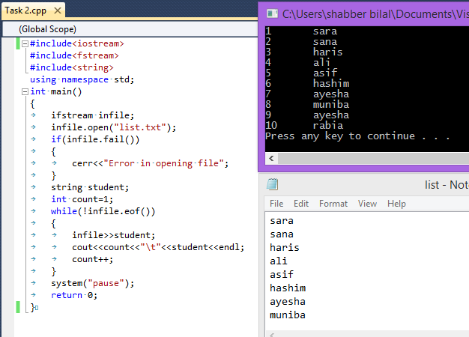

**TASK 3**

**Objective:**

Write a program to read the text file student and print on console.

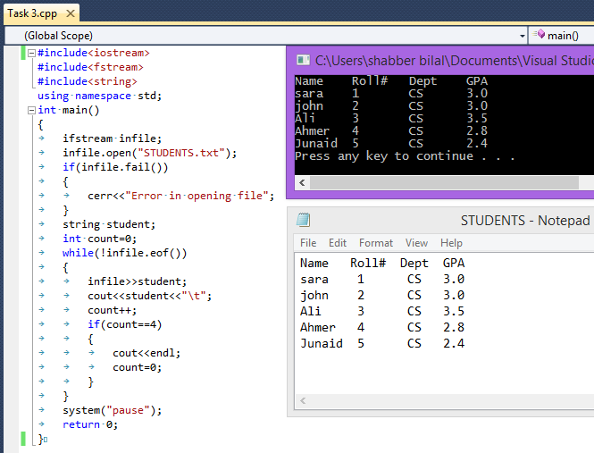

**TASK 4**

**Objective:**

Write a program to read the text file line by line and print on console.

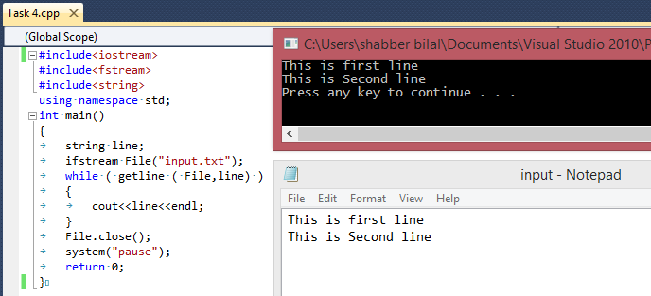

**TASK 5**

**Objective:**

Write a program to input name and age of two persons and save data into file

Example

Sara 24

John 30

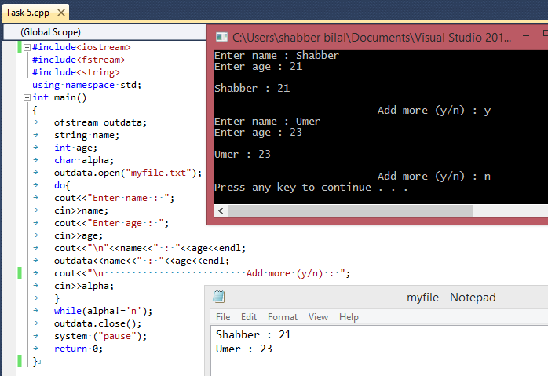

**TASK 6**

**Objective:**

Write a program to read a text file and count number of words and sentences in a file.

